

**NERIUM OLEANDER**

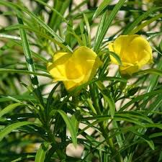**BOTANICAL NAME: *Nerium Oleander***

**FAMILY:** Dogbanes

**SYNONYMS:**

**ENGLISH:**Oleander

**HINDI:** Kaner

**TAMIL:** Neriyam

**TELUGU:**Neriyam

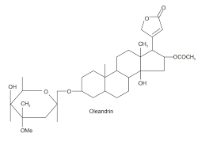**CHEMICAL CONSTITUENTS:**

* Glycosides, neriin and, and an alkaloid, oleandrin
* phenols, tannins, flavonoids, coumarins, phlobatannins, sterols and triterpenes, and alkaloids.

**USES:**

* Oleander is popular in landscaping for its dense foliage and vibrant, long-lasting flowers. It's commonly used in gardens, parks, and as a hedge plant.
* Its robust root system makes it useful for controlling soil erosion on slopes and embankments.
* Some research has explored oleander extracts for their potential anticancer properties. The plant contains compounds that have shown promise in laboratory studies, but more research is needed to determine their effectiveness and safety.
* Oleander's dense foliage makes it an effective windbreak in certain climates.
* The flowers attract pollinators such as bees and butterflies, contributing to the local ecosystem.